The mass protests against racism in the US
A taste of the gathering storms against the imperialism and all reactionaries

Mass protests in the US have entered their third week spreading to hundreds of cities in all 50 states of the country. Hundreds of thousands of young and old have poured out in the streets to protest against racism, police violence and brutality across the country. So far, more than 10,000 people have been arrested during these largely peaceful and just protests. Several major US cities have imposed curfews further extending police powers in an attempt to stop demonstrations and curb unrest. Police forces have continued to use brute force deploying pepper spray, rubber bullets, teargas and batons on protesters and bystanders. In at least 21 cities the National Guards were dispatched to suppress the mass protests against police brutality. Despite the extent of repression and Mr Trump's, public attacks and threats to deploy the army and use lethal weapons to end the protests, in most cases, the militant protestors have ignored the curfew and have taken measures to counter the reactionary violence of the state forcing the security forces to retreat. Naturally, this unprecedented militant resistance against armed police has alarmed the ruling classes uniting the democrat and the ruling republican parties in condemning violence and the unrest.
The recent protests were sparked off as a response to the brutal murder of George Floyd, a 46 year African American by the police in the city of Minneapolis in Minnesota on May 25th. The arrest and the use of brute force on George Floyd by the police officers that held him pinned to the ground for almost 9 minutes and caused his death was captured on video by bystanders and made public through social media. During the hold down, Floyd is clearly heard repeatedly saying "Please, I can't breathe!" The detailed documentation of the incident utterly exposed the local police authority's lies that claimed he was held down while resisting arrest and died on the way to the hospital.
The extraordinary scenes of protests and violent clashes with the police and authorities across the US are merely an expression of the tremendous outpouring of anger and fury by the oppressed people against the system that is based on injustice, discrimination and violence against the African American population, other minorities and the poor in the US.
This was neither the first nor the only recent killing of an African American in the US by the police in recent weeks that has unleashed the anger of the communities across the country. During the past year alone over 1000 such killings by the police have been recorded. The overwhelming majority of those killed were African Americans. In most cases, the authorities have justified these killing and refused to investigate or bring to justice the perpetrators of these crimes. However, in the case of Mr Floyd's murder by the police, the video evidence is so brazen and clear that it has raised public outrage and despite the isolation and distancing rules has mobilised the masses of people from all sections of society.
Clearly, the protests today are the result accumulated, and pent up anger and frustration gathered through decades of systematic racism, discrimination, injustice and the open violence that has been fomented by the ruling classes of the US imperialism and their state machinery representing the monopoly capital.
This unprecedented upsurge sparked off by the police killing of Mr Floyd occurs in the midst of the global pandemic where because of the blatant indifference of the ruling classes only in the US over 100,000 people have fallen victim to the virus. All statistics show that a very high percentage of deaths have occurred amongst African American and other sections of working-class poor. The lockdown and the downturn in the economy too has hit the poorest communities the hardest. Official numbers of people registering for unemployment in the US, in less than two months has risen from 2.5 million to 30 million and still rising. While many joining the protest are motivated by the urge to oppose and stamp out racism and discrimination, the underlying factor giving rise to the magnitude of protests is essentially the bare-faced class oppression of the working class that a large number of African Americans communities are a part.
In the meantime, the US administration of Mr trump representing the US imperialism as the dominant imperialist power in the world is seen to be most concerned about losing its position to contending imperialist powers such as China and continues to flaunt its power, projecting it through threats, boycotts, blackmail and sanctions and continues to shift the blame for its troubles at home on external factors and foreign powers. While home, all claims to freedom and democracy, human rights, land of opportunities, … is being torn to pieces by the masses in the streets exposing the true nature of monopoly capitalist class as bigots, racists, warmongering and reactionaries.
The struggle of Afro-American people against US imperialism has along with bloody history. In 1968, following the criminal assassination and murder of Martin Luther King in the US, Comrade Mao Tse-tung, issued a message of solidarity entitled "A new storm Against Imperialism". Here is only a part of this revolutionary message by Mao Tse-tung:
"Racial discrimination in the United States is a product of the colonialist and imperialist system. The contradiction between the Black masses in the United States and the U.S. ruling circles is a class contradiction. Only by overthrowing the reactionary rule of the U.S. monopoly capitalist class and destroying the colonialist and imperialist system can the Black people in the United States win complete emancipation. The Black masses and the masses of white working people in the United States have common interests and common objectives to struggle for. Therefore, the Afro-American struggle is winning sympathy and support from increasing numbers of white working people and progressives in the United States. The struggle of the Black people in the United States is bound to merge with the American workers' movement, and this will eventually end the criminal rule of the U.S. monopoly capitalist class." [https://www.marxists.org/reference/archive/mao/selected-works/volume-9/mswv9_80.htm]
Today, 52 years after this message, many things have changed. These include the restoration of capitalism in China in 1976 and the emergence of China as an imperialist power on the world scene and the setbacks to the cause of proletarian revolution in many countries. But what has not changed is the nature and the character of the monopoly capitalism and the intensified offensive of imperialism against the workers and oppressed peoples of the world amid the endemic crisis of capital. The revolutionary essence of the message of solidarity and the analysis by the comrade Mao Tse-tung representing the international proletariat, calling on the workers and the oppressed of the world to unite against US imperialism and all reactionaries remains as valid as in 1968 and find renewed urgency and resonance, today.
Today, the crisis that highlights the common interests and common objectives for struggle workers and the oppressed is no longer limited to US imperialism; it has engulfed the whole of the capitalist-imperialist system further intensifying all inherent contradictions of the imperialist system. Following the financial crisis of 2007-8, where the whole world was thrown into a deepened economic and political crises and with no recovery in sight the bourgeoisie in all countries, imposed further reactionary and harsh "austerity" measures causing decades-long devastation to the lives of the working class and the oppressed everywhere.
Today, the world is about to emerge from the spread of the COVID 19, and we are about to witness the crippling consequences of the economic shutdown, further plunging the whole imperialist system into an unprecedented economic, social and political crisis that will bring untold devastation to largest sections working class and the oppressed everywhere.
Under these conditions, the mass mobilisations of the oppressed in the US fighting against racial discrimination is a clear sign of the upcoming future and more significant storms on the horizon. No doubt the ruling classes everywhere will use all their resources to suppress and contain these upsurges. No doubt they will also use the fear of the spread of Coronavirus and the pandemic to impose curfews and isolation. However, as the mass protests in the US demonstrate, the oppressed masses will brush these aside knowing that the continued domination of the imperialist system is far more a danger to their lives and future than danger brought about by any natural disaster or viral pandemics.
Let us join together and raise the banner of solidarity and proletarian internationalism to intensify the class struggle and redouble our efforts and preparations to greet the revolutionary storms of workers and the oppressed peoples' struggle against the whole capitalist-imperialist system. We have nothing to lose but our chains!

TKP-ML International Bureau
13 June 2020

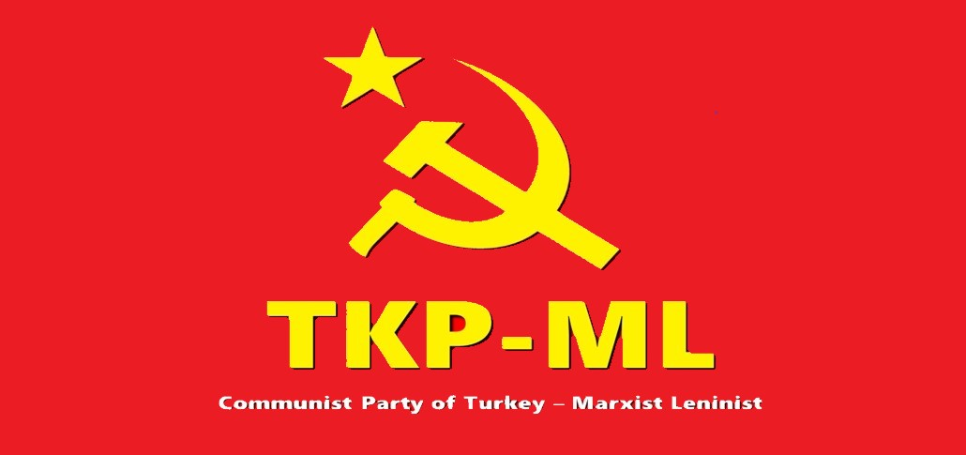
Link: https://www.tkpml.com/tkp-ml-international-bureau-the-mass-protests-against-racism-in-the-us/

