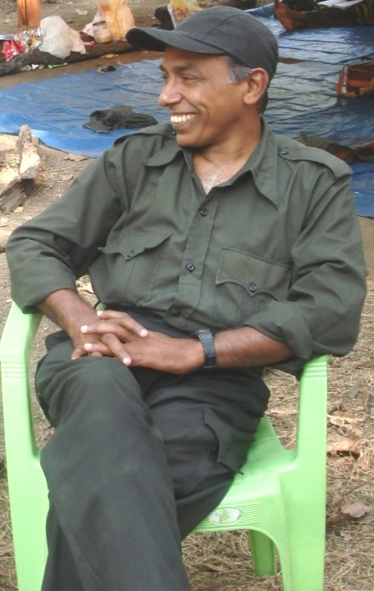
Comrade Kishenji (Mallojula Koteswara Rao) — 1954-2011

