With the Struggle We Have Woven and Organized with Our Labor, Let Us Uproot and Destroy the Patriarchal System!
Today, as millions of women across the world, we once again mark March 8, International Working Women’s Day, as a crucial milestone in our struggle for freedom, defending our labor, our rights, and our human dignity. For March 8 is not a celebration but a vital tool for advancing our struggle towards liberation—especially at a time when the fascist dictatorship in our country intensifies its exploitation and oppression, when imperialist aggression and the devastating consequences of wars escalate, and when our bodies and labor are subjected to ever-increasing forms of repression.
Imperialism, just as it oppresses the peoples of the world, crushes working women in a vicious cycle of exploitation and violence. Neoliberal policies, wars raging across the globe, unemployment, poverty, and environmental disasters systematically impoverish women, steal their lives, and condemn them to slavery. Today, women around the world are not only victims of economic crises but also of wars. According to United Nations data, women in countries affected by war, occupation, and conflict suffer 70% more victimization. The barbaric attacks women face in war, sexual violence, rape, and enslavement, stand before us as the most savage face of imperialism.
We, as women, are not only the victims of wars but also those who bear their heaviest burdens. We are the ones displaced from our homes and lands, subjected to torture and violence, forced to live in misery as migrants, cast out socially and economically, and devastated in every possible way. Let us not forget: the ever-growing number of migrant and refugee women is a direct consequence of the destruction wrought by wars and capitalism.
Imperialism does not only make us women the victims of wars and economic crises, but it is also the very system that exploits women and sustains their status as second-class citizens. Today, also women in Turkey are deeply affected by the destructive effects of this global order. The country’s economic crisis, unemployment, inflation, and precarious working conditions disproportionately target women and LGBTQ+ individuals. While the female labor force participation rate in Turkey hovers around 30%, this figure not only highlights the exclusion of women from the workforce but also exposes the extent of workplace discrimination they face. Women are subjected to wage inequality, job insecurity, and a concentration in low-paid jobs, leading to the ruthless exploitation of their labor. Meanwhile, the AKP-MHP government, which erects police barricades to protect bosses against every worker’s strike and action demanding rights, does everything in its power to crush our struggle.
But this is not all. In recent years, there has been a severe regression in women’s and LGBTQ+ rights in Turkey. Patriarchal control over women’s bodies has intensified, and since the government's withdrawal from the Istanbul Convention in 2021, the AKP has been systematically weakening laws against gender-based violence under the guise of "protecting the family," further increasing women’s insecurity. Violence against women has become a daily reality, often culminating in femicides, while the state and judiciary’s stance has only reinforced this culture of violence.
The declaration of this year as the “year of the family” signals that this state of insecurity will only deepen further. Last year, 68% of femicides were committed by a former or current husband or partner, making it clear that the family itself is a fundamental security threat for women. The ongoing attempts to abolish our already inadequate and poorly enforced alimony rights are yet another means of trapping us within the prison called the “family.”
At the same time, the hard-won rights over our own bodies continue to be attacked through anti-women legislation. Our right to abortion has been under severe threat in recent years, and the AKP government’s rhetoric about restricting abortion is nothing but an attempt to strip us of the right to make decisions over our own bodies.
“We Will Win Through Organized Struggle!”
The aggressive policies of imperialism, the growing threat of war, and the worsening economic and social conditions of women and LGBTQ+ individuals in our country call on all of us to organize, unite in solidarity, and fight back.
Despite this bleak reality, the women's struggle must raise its voice in every sphere, from the streets to the factories, from schools to workplaces. We must organize more every day, expand the resistance, and wage an uncompromising fight against the patriarchal system. And we must do this not only for our own rights but for the true liberation of the working class and the oppressed masses.
Throughout history, we have resisted, fought, and won victories! Now, as women from Turkey and all around the world, let us once again raise the banner of our struggle even higher and proclaim our fight for equality, freedom, and justice.
The struggle ignited in 1857 by the textile women workers in New York, at the cost of their lives, continues and will continue in every corner of the world!

Long live International Women’s Solidarity!
We will fight, and we will win against Imperialist war threats, Fascism, Racism, Poverty, and Patriarchy!
Long live our party TKP-ML and KKB
TKP-ML KKB
March 2025
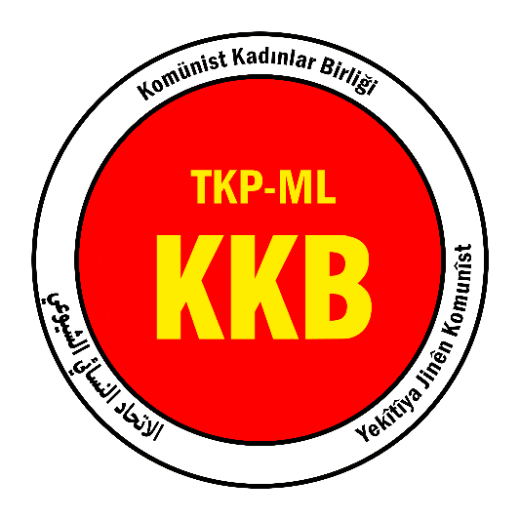

Link: https://www.tkpml.com/tkp-ml-kkb-with-the-struggle-we-have-woven-and-organized-with-our-labor-let-us-uproot-and-destroy-the-patriarchal-system/?swcfpc=1

