The Palestinian People Are Not Alone!
We Stand By The Resisting Palestinian People!

The sharpening of the inter-imperialist contradictions and the reorganization of the relations with the regional reaction in the Middle East together with the power struggle brought the Zionist state of Israel to attack the Palestinian people once again. Israel's policy of occupation, annexation and slaughter against the Palestinian people continues.
Finally, Palestinians living in the Sheikh Cerrah Quarter of occupied East Jerusalem were subjected to the Zionist regime's occupation and forced migration threats. Palestinians who resisted faced assault, detention and arrest. In the face of this just and legitimate struggle of the Palestinian people, the Israeli occupation forces launched an air attack on the Gaza Strip and as a result of the attack, 9 Palestinians, 24 of them children, were killed.
This aggressive attitude of the Zionist Israeli regime towards the Palestinians was supported by the US and EU imperialists. The Arab League, on the other hand, only condemned Israel for "attacking without a target". The fascist TC, the most loyal servant of the USA in the region along with Israel, declared that it "strongly condemned" the aggression!
Our party stands by the just and legitimate struggle of the Palestinian people against imperialism, Israel Zionism, its invasion and annexation attacks. The pretext for their last attack is Sheikh Cerrah Palestine, it belongs to the Palestinians.
However, the statements of the fascist TC denouncing Israel and expressing its support for the Palestinian people are hypocritical. The fascist Turkish state is one of the last states to condemn Zionist Israel. Because, while developing its commercial relations with the Israeli state on the one hand, on the other hand, the Palestinian land accepts Jerusalem as the "capital of Israel" in international agreements with Israel.
Just as the Zionist Israeli regime invaded and annexed the Palestinian territories, the fascist Turkish state also occupied Afrin, Al Bab, Gire Spi-Serekaniye. The fascist TC carried out massacres in these regions with both its own forces and ISIS leftover gangs and is taking steps for annexation. A similar situation is happening in Iraqi Kurdistan. The fascist TC is in a comprehensive attack on the Kurdish National Freedom Movement. It aims to occupy the region and annex it in the long term.
The Zionist Israeli regime and the fascist Turkish state are like two sides of the coin. They are loyal servants of the US and EU imperialists in servitude to imperialism and aggression towards the peoples of the region. Therefore, the Turkish condemnation of Israel is false, hypocritical.
The Palestinian people continue their resistance and struggle based on long years. With the submissive and conciliatory line of the leadership of the Palestinian National Liberation Movement, he does not accept the submission and dishonor imposed on him, even though he has lost important positions and has been deemed a refugee in his own land.
The resistance of the Palestinian people against imperialism and Zionism, occupation and massacre attacks is legitimate and must be owned.

Long Live The Honorable Resistance of the Palestinian People!
Long Live the Right to Leave Freely!
Down with Israeli Zionism, Imperialism and All Reaction!

TKP-ML Middle East Party Committee

May 11 2021

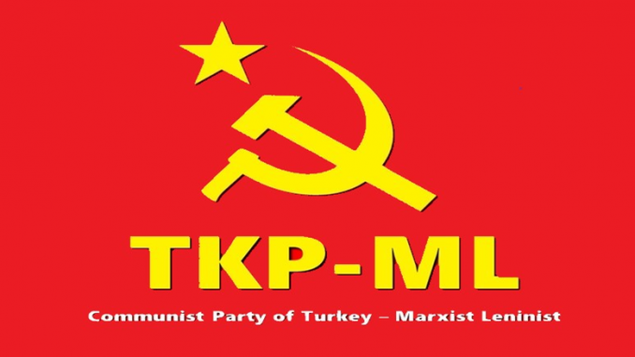
Link: https://www.tkpml.com/tkp-ml-middle-east-party-committee-the-palestinian-people-are-not-alone/

