Dozens Detained Amid Maoist-Led Rights Campaign at Chinese Factory
2018-07-30

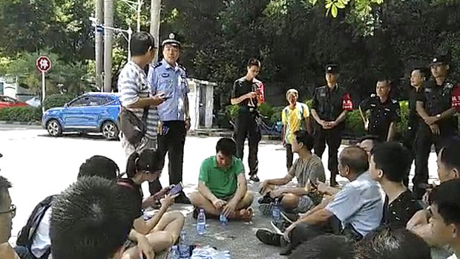
Police speak to supporters of striking workers at Jasic Technology in Shenzhen, China, July 30, 2018.
Photo sent by an RFA listener
Authorities in the southern Chinese province of Guangdong are holding dozens of workers at a technology factory after they tried to set up their own trade union with the help of Maoist activists.
More than 20 workers at Shenzhen Jasic Technology are being held on suspicion of "picking quarrels and stirring up trouble," after their cause was supported by a group of Maoists from the far left of China's political spectrum.
On Monday, activist Shen Mengyu and 14 other supporters were themselves held briefly by police, and subjected to "legal education," in a local police station, before being released late on Monday, the group said via Twitter.
"We're out!" Shen says in a video statement posted by supporters to Twitter.
"This afternoon at about 5.00 p.m., on our way back from handing in our open letter to party secretary Tao Yongxin at the Pingshan [district] government, we were intercepted and forcibly brought to this police station for questioning by a huge group of police officers."
We were released only after undergoing legal education," he said.
Before her detention, Shen told RFA that a number of workers remain in criminal detention that could lead to criminal prosecution on public order charges.
"They still haven't released the workers," she said. "It's been nearly three days now. We heard ... yesterday that they are now being held under criminal detention."
"However, you should be able to find the information you need online. I can't really give interviews."
'Picking quarrels'
An anonymous source close to the protests told RFA that the workers were detained by police from the local Yanziling police station.
"When Shen Mengyu went up there with around 20 supporters ... a police officer came out and said that they they have more than 20 people now being held under criminal detention for 'picking quarrels and stirring up trouble'," the source said. "They haven't issued any documentation, though."
"They have been transferred to the detention center," the source said.
An employee who answered the phone at the Yanziling police station on Monday declined to comment.
"We can't confirm your identity over the phone, so we can't very well give telephone interviews," the employee said. "You can contact our publicity department."
Calls to the supplied number rang unanswered during office hours on Monday.
According to the open letter delivered by Shen and fellow activists, Jia Lei, owner of the Jasic factory and personnel manager Guo Liqun are both delegates to the Shenzhen People's Congress, a rubber-stamp body entirely controlled by the ruling Chinese Communist Party. Guo's husband is also a high-ranking official in the local government.
"We hope that party secretary Tao Yongxin will immediately deal with this matter, urge the police to release the detainees immediately, and severely punish those who beat up the workers, compensate them for their losses, and apologize," the letter, a copy of which was available on the overseas documentation site HackMD, said.
"The Pingshan government and the regional branch of the All China Federation of Trade Unions (ACFTU) should pay attention to directives from the central government, and encourage these workers to set up a union for the legal protection of their rights, and to play a positive and supervisory role in managing the company," it said.
The detention of workers came on July 27 as they protested the dismissal by factory management of those involved in a bid to set up a union through legal channels.
"No illegal dismissal! We want to go back to work!" they chanted in a protest last week outside the factory. Protesters also sang the communist anthem The Internationale, Hong Kong-based labor rights group SACOM reported.
Beaten by police
Seven workers also said they had been beaten up by police for their involvement in the campaign to found a union.
"When the police came, they knocked us to the ground without a second thought and started to beat us up," one of the seven said in a video statement posted to SACOM's Facebook page. "This is discrimination ...They treat ordinary people and the bosses quite differently."
A source close to the protests who gave only his surname Chen said more than 30 people had been detained, while dozens of Maoist activists had protested on their behalf outside the local police station.
Some Maoists had deliberately sought employment at the Jasic factory in the hope of helping the workers stand up for their rights, Chen said.
"The workers wanted to set up a trade union to protect their rights," he said. "The Maoists thought that they needed to unite the workers, and that a union would act as a breakthrough for them, so they came over to support them."
"Around 90 percent of the supporters are Maoists, who actually carry copies of the Thoughts of Chairman Mao and banners with Chairman Mao's image on them."
"There are also a few liberal-minded people involved, but they all have the same aim."
Momentum lost
Chen said activists had started their action on July 18 ... and about 30 people had been detained since, on suspicion of "picking quarrels and stirring up trouble."
He said Jasic employs around 1,000 workers, but suggested that the movement may be losing some momentum among workers on the shop floor after the crackdown by the authorities.
"Some people have been appeased by management," Chen said.
Democracy activist Ren Ziyuan, who has previously served a 10-year jail term, said Shen was among those who sought jobs at the factory with a view to helping the workers organize.
"She was employed at the factory, and then she helped them to unionize to fight for their rights," Ren said. "That's pretty unusual."
"But she believes in all that Maoist stuff, in communism, which is a pity," he said. "They believe that Mao stood up for the rights of workers, and they believe that the famines of the Great Leap Forward [1958-1960] were all a lie ... they think that the figure of 38 million dead in the famine was all cooked up by the rightists, and that's why Mao went after them."
Reported by Lau Siu-fung for RFA's Cantonese Service, and by Yang Fan for the Mandarin Service. Translated and edited by Luisetta Mudie.

From: https://www.rfa.org/english/news/china/factory-07302018150907.html (July 31, 2018)
Note the obligatory anti-Maoist comments by the so-called “Radio Free Asia” at the end of the article.

