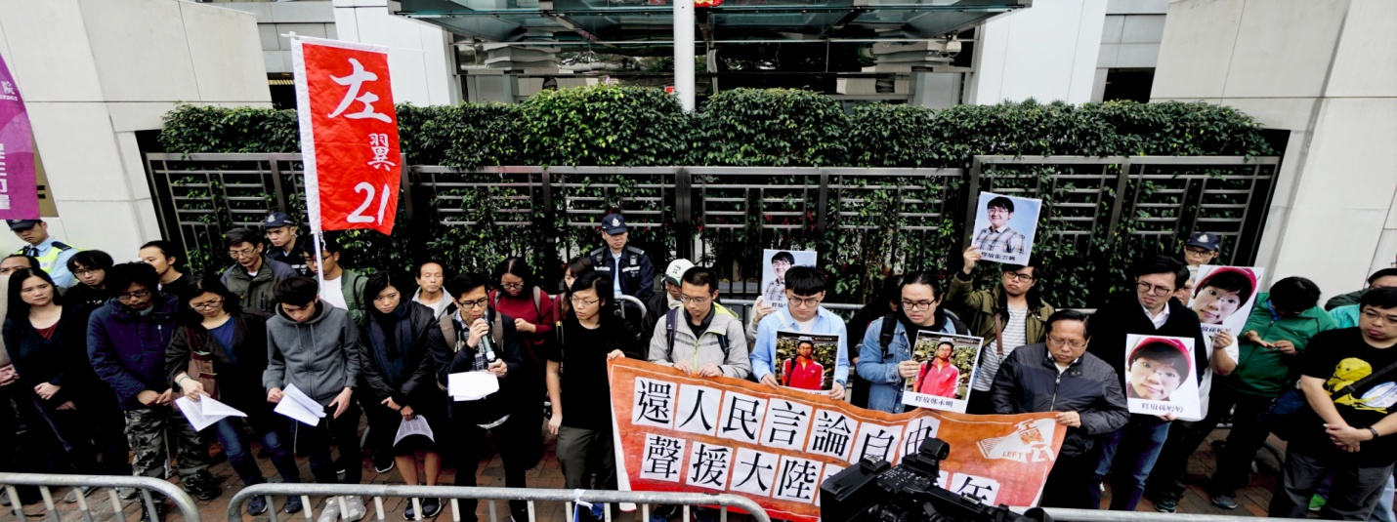

In Support of Young Leftwing Activists Detained and Wanted for Organizing a Reading Group on November 15 2017

On November 15 2017, an ongoing reading group organised by a group of university students and recent graduates in a classroom of the Guangdong University of Technology was cracked down by local police. 6 participants were seized, among which Ye Jianke and Zhang Yunfan were later locked up as criminal suspects. Zhang Yunfan was first accused of involving in “illegal business operations”, but later taken under police custody in the Panyu Detention Centre for “gathering crowds to disrupt social order”. The police also stormed into the residence of Zheng Yongming and Sun Tingting, who are also organisers of the reading group and labour activists, and then put them under criminal detention on December 5 and 8 respectively. In an open letter released by Zhang Yunfan on January 15 2017, he mentions that the June 4th incident in 1989 was discussed during the reading group session. The open letter also reveals that that 4 persons (Zhang Yunfan, Ye Jianke, Zheng Yongming and Sun Tingting) are in fact released on bail for a pending trial. Yet 4 other people including Xu Zhongliang, Huang Liping, Han Peng and Gu Jiayue are still wanted as criminal suspects.
The incident has drawn widespread public attention. Last month, more than 400 academics, students and social activists with political stances from across the spectrum initiated a petition in support of Zhang Yunfan and the others. Under confinement and police threat, Zhang Yunfan could do little but compromise, but the open letter written after his release demonstrates that he still sticks to his principles by telling the truth and making his experience known to the public. Meanwhile, Sun Tingting and Zheng Yongming also wrote against the police actions. Their public outcry against the crackdown and support from people with different ideological stances demonstrate the courage of Chinese citizens to speak out despite the increasingly oppressive political environment in China.
The unjustified detention of Zhang Yunfan and others does not simply affect their rights of organising read groups and concern about labour issues on campus, but also pose a threat to the freedom of speech and other basic civil rights of all Chinese citizens. If merely discussing social affairs in a reading group is so abruptly oppressed, is it still possible for ordinary citizens – particularly workers and peasants – to enjoy freedoms of speech and other sorts in any case? Is it still possible to defend their rights with the freedom of speech and association? Zhang Yunfan and Zheng Yongming position themselves as left-leaning who remain “loyal to the working class and faithful to Marxism”, and they do show compassion towards workers and the subaltern. Apart from organising readings groups, other left-leaning young people are involved in the production of a recently published investigative report on the working conditions of support workers in Peking University, as well as other community activities to “help underprivileged workers and peasants at the bottom of society to live with dignity”. In China nowadays, their persistent concern about welfare of the underprivileged and critical edge on social injustice is rare and respectable. The fact that they are oppressed in this way reveals how the Chinese government actually sides against the working class.
We support the freedom of speech for Zhang Yunfan and the others, and protest against unjustified arrest and detention, even though we are not necessarily in line with the Maoist perspectives that they believe in. For instance, we do not endorse the judgement of some Maoists on the rule of Mao and their conservative view on democracy. We believe that the leftwing should advocate for an authentic democratic system, under which the working class manage to seek political authority on the basis of political freedom (including the freedom to form different political parties), transcend the despotism of the capitalist class and state bureaucracy, and progressively establish a truly egalitarian and peaceful society without class distinction and exploitation. We are open to public debates or even criticising the Maoist stances, but we are strongly against dismissing anyone’s rights to discuss social issues and express political views freely. We remain respectful to the left-leaning students and young people, who sincerely persist on advocating for the wellbeing of the masses in this authoritarian regime but still suffer in this incident.
Real democracy and socialism will not be achieved without the freedom of speech and other civil liberties. We call for the attention of citizens in Hong Kong and Taiwan to the development of this incident. Transregional solidarity with students and workers from mainland China striving for political freedom is of utmost importance to terminate the oppression of the Chinese Communist regime on all citizens, and to free civil liberties from threat in all regions.
Organising reading groups is not a crime. Discussing the June Fourth Movement is not a crime. Oppression is not justifiable. We strongly urge for:
- Unconditional revocation of charges of Zhang Yunfan, Sun Tingting, Zheng Yongming and Ye Jianke; discontinuation of searching for Xu Zhongliang, Huang Liping, Han Peng and Gu Jiayue.
- Immediate access to freedoms of speech and publication nationwide; release of all political prisoners; prohibition of unlawful detention which oppresses the freedom of speech, so that everyone enjoys the right to express their views freely.
- Immediate access to the freedom of association, so that workers are able to organise independent from monitoring and control; an end to the one-party rule to give room to free competition among independently organised political parties; a representative body of all citizens with universal suffrage; a democratic political system and functional legal system to protect civil rights of all citizens.
- Disciplinary measures on the Panyu Police Bureau for unlawfully detaining Zhang Yunfan and the others.
- Rectification of social problems and a just society.

Endorsed by :
Left 21
Labor Committee of Neighbourhood and Workers’ Service Centre
Student Labour Action Coalition
Labour Party
League of Social Democrats
Hong Kong Alliance in Support of Patriotic Democratic Movements of China
Autonomous 8a
Borderless Movement
New School for Democracy
Demosistō
Socialist Action
NTUNINEWS
NTUcontinent Taiwan International Workers’ Association(Taiwan）
National Alliance of Workers Victimized by Plant Closure(Taiwan）
Editorial Board of Red Balloon Solidarity
Hong Kong Confederatiion of Trade Unions
International Labour Defense
YiLan County Confederation of Trade Unions
LabourNet Germany
Alliance of Middle Eastern Socialists
MARCH 10, 2018 BORDERLESSMOVEMENT 最新文章

