Images of the Combative Protests by the Masses
against the Pope during His Visit to Brazil (July 2013)

Mais imagens dos protestos durante a visita do Papa, mostrando imagens de faixas e bandeiras da Frente Revolucionária. [More images of the protests during the visit of Pope, showing banners and flags of the Revolutionary Front.]

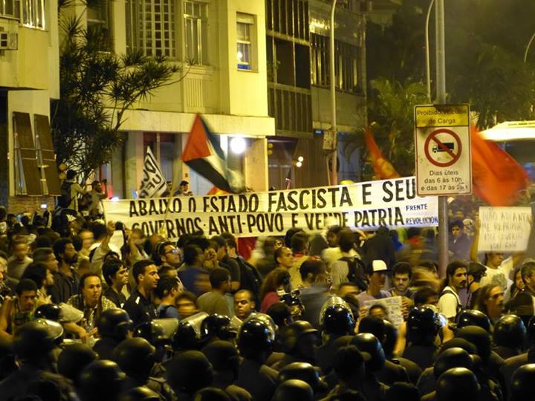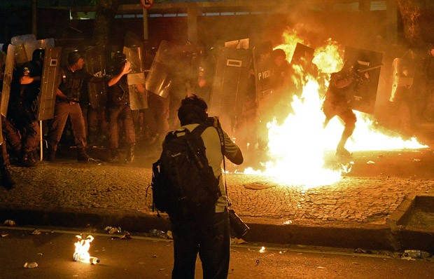

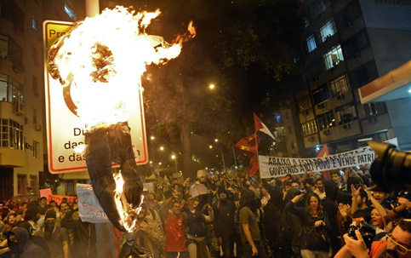
The Pope burning in effigy
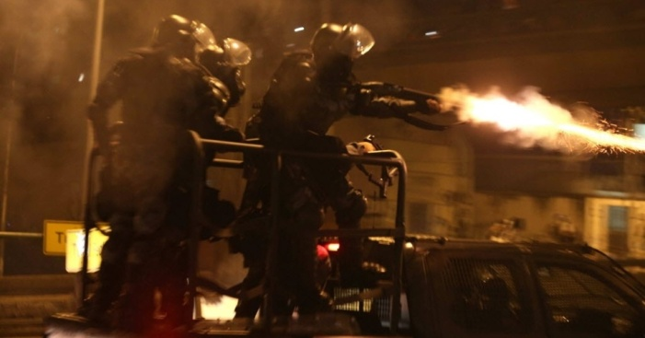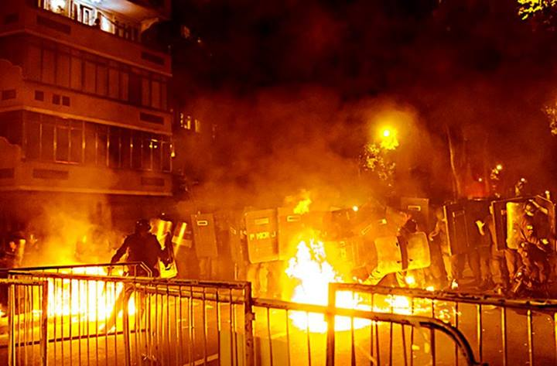
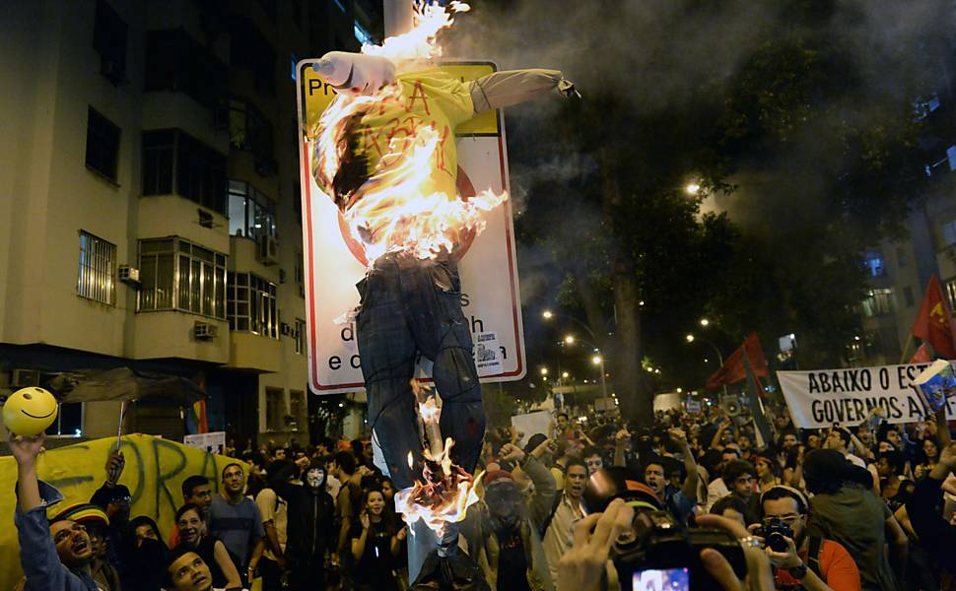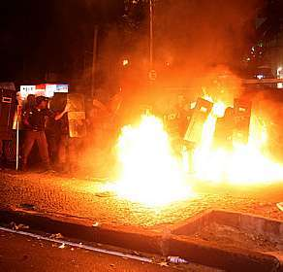

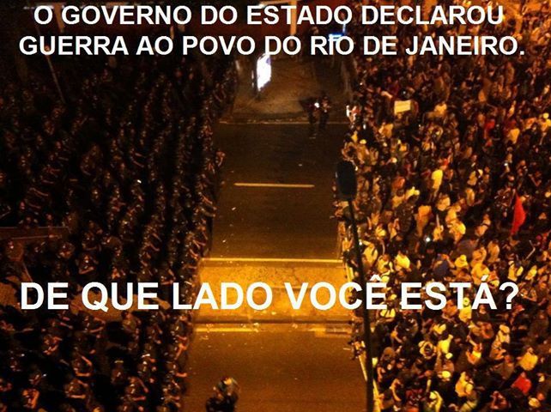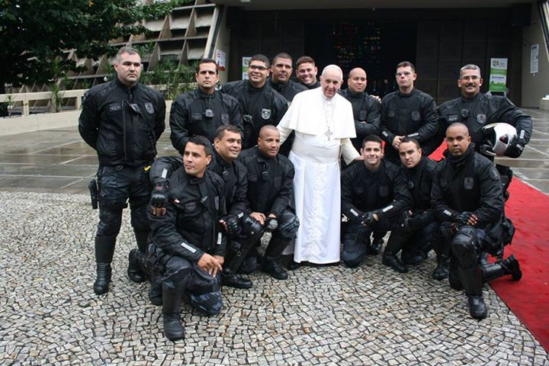

These photos and others are available at: https://groups.yahoo.com/neo/groups/MAOIST_REVOLUTION/attachments/2044052117

Videos on YouTube:

http://www.youtube.com/watch?v=c80v1P_N7KU&feature=c4-overview&list=UU7G7saR0vFSMh-SdEyF3Utg

http://www.youtube.com/watch?v=CSALinLOSRs&feature=c4-overview&list=UU7G7saR0vFSMh-SdEyF3Utg

http://www.youtube.com/watch?v=Edw2a-N0AuU&feature=c4-overview&list=UU7G7saR0vFSMh-SdEyF3Utg

