We Are In Solidarity With The Colombian People!
"IF THERE IS NO BREAD, THERE IS NO PEACE FOR THE RICH!"

In Colombia, one of the South American countries where 30 per cent of coronavirus-related deaths are experienced worldwide, the people rebelled against the conditions imposed on them. The fascist Colombian state and the government of Iván Duque have drafted the "Solidarity Financing Law", a tax reform that will impoverish the majority of the population, let alone take adequate measures against the epidemic.

With this reform, which is derisively called "Sustainable Solidarity", the Colombian state aimed to increase wage and food taxes for the lower and middle classes and to lower taxes on the income of large companies. This step of Iván Duque involved an overtly fatal class attack on the Colombian people, who were left alone in the face of the virus and tried to be disciplined with openness and poverty.

The people of Colombia courageously resisted this attack on them. A nationwide general strike was called on April 28. Millions of workers, peasants, youth, women and LGBTI +, unemployed, artists and retired responded to the call. The people took to the streets, filled the squares and set up barricades. The Colombian state and the Iván Duque regime attacked this honourable uprising of the people. Tens of people were killed, hundreds were injured, tortured, raped and arrested.
While the state responded to the uprising of the people with fascist aggression on the one hand, on the other hand, it resigned for the show, Finance Minister Alberto Carrasquilla, who prepared the attack under the name of reform. The Duque regime had to make the known statement in the face of the honourable revolt of the people and called for "national dialogue" but continued the popular revolt of dignity.

While the people are in revolt in pursuit of their bread, they target the statues of colonialists in cities, as we often see, especially during the Black Lives Matter movement.

The massiveness, militancy and prevalence of the Colombian people's revolt are directly proportional to the attacks directed against it. There is a deep gap between public unemployment, poverty, hunger and poor living conditions, high spending on the military budget and the luxurious lives of the Iván Duque regime and its supporters. The people are struggling against these living conditions imposed on them. Due to this struggle, more than 250 people, including trade unions, peasants and people's leaders, were massacred by the paramilitary forces of the state in 2020. This year, the exact number of those killed by the protests is unknown.

What happened in Colombia should be seen as a short fragment of what will happen around the world in the future and the honourable stance of the people sets an example for the peoples of the world.

We express our solidarity with the revolt of the Colombian people.
We condemn and damn the Iván Duque regime for its fascist aggression against the Colombian people.

The struggle of the Colombian people is not alone!
Long live international solidarity!

Communist Party of Turkey - Marxist Leninist (TKP-ML)
International Bureau
May 2021
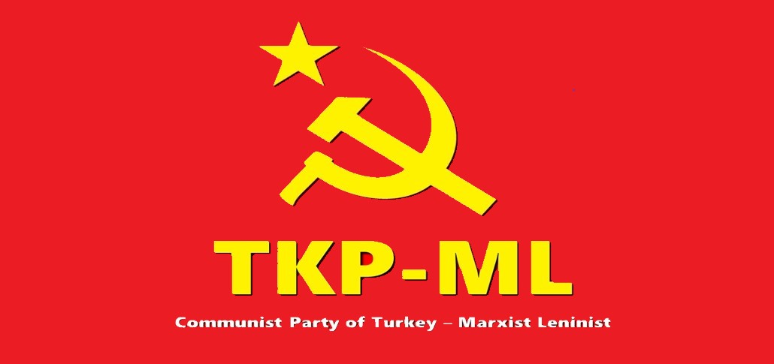

Link: https://www.tkpml.com/tkp-ml-international-bureau-we-are-in-solidarity-with-the-colombian-people/

