Communist tribute to Ka Oris, the senior commander and spokesperson of
New People’s Army!
We will keep his memory alive in our struggle!

We respectfully commemorate Comrade Oris, who was murdered by the Philippine army in a treacherous ambush, on behalf of our party Communist Party of Turkey. The assassination of Comrade Ka Oris, who dedicated his life to the Philippine revolution, and Ko Pika, added to the crimes committed by the Duterte regime against the people and revolutionaries.
We are very proud to be the comrade of Ka Oris, who made great efforts and played an important role in the growth of the New People's Army, which he joined as a young revolutionary in the early 1970s. This esteemed communist, who won the great love and respect of the Filipino peasant and worker masses, will always be remembered with respect by his comrades in Turkey.
For communists, prisons, the most unfavorable conditions, are seen as a part of the struggle against fascism, and every field they are in becomes a field of struggle. Ka Oris was also captured and spent 5 years in prison after peace talks with the Corazón Aquino government collapsed in 1987. Apart from this 5-year “interruption”, Ka Oris has carried out extremely successful activities in the service of the Communist Party of the Philippines, the New People's Army and the Filipino people.
Ka Oris and our comrades like him so terrified the Philippine state that The PH Army's Eastern Mindanao Command led by Lt. Gen. Greg Almerol awards medals to the commanders of 4th ID for their campaign against People's War, after the assassination of Ka Oris. The fascist state of the Philippines and its army are perfectly justified in being afraid. The medals they wear around their necks cannot hide their fears. Because they know that the Communist Party of the Philippines and the New People's Army are doing their best to make their fears real.
Comrades like Ka Oris leave a great void when they become immortal. However, we should not forget that "Revolutionaries die, but revolutions don't stop, they continue!" As it's said in the CPP-CC statement “By taking his life, the fascists have only succeeded in immortalizing Ka Oris.” The Filipino communists and the New People's Army will fill the space left behind by Ka Oris and will achieve new successes in the Protracted People's War.
In conclusion, we would like to end with the following words of Comrade Ka Oris: “We all die, either by the bullet or in sickness. It doesn’t matter. The most important for the old or the young is not if we die or live but if we persevere for our cause is just. While the cause of the other side is for logging, for mining, for expanding plantations in the interests of foreigners and local politicians who serve as lapdogs of multinational corporations. The difference is immense. If we die, we die. They won’t die because they have the military defending them. But it doesn’t matter. The revolution continues. As you can see there are many young people in our army. That is why it’s called New People’s Army. Because so many of them are youngsters. Up to now, it’s still “new people”. We will go on, we will continue when Ka Oris is no more. The revolution does not revolve around Ka Oris. The revolution does not revolve around the Tiamzons. Revolution belongs to the people. It is not for us old ones to claim that the revolution has advanced because of us. The revolution is advancing because it has the basis to advance. The people want change.”

Long live Marxism-Leninism-Maoism!
Long live the People's War!
Long live proletarian internationalism!
Martyrs of revolution and communism are immortal!

Communist Party of Turkey - Marxist Leninist (TKP-ML)
International Bureau

November 2021

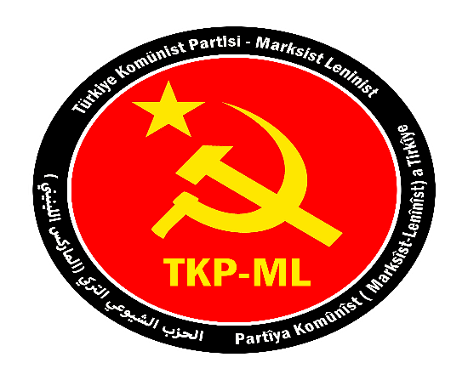

Link: https://www.tkpml.com/tkp-ml-international-bureau-communist-tribute-to-ka-oris-the-senior-commander-and-spokesperson-of-new-peoples-army/?swcfpc=1

