Statement No: 2021/3

HAPPY 49TH ANNIVERSARY TO OUR PARTY ESTABLISHED IN THE LIGHT OF THE PARIS COMMUNE!
FROM NOW TO FUTURE: MORE PERSISTANT AND MORE DETERMINED!

TKP-ML was established on April 24, 1972 under the leadership of İbrahim Kaypakkaya with limited number of cadres in the practice of class struggle. This year, in which we celebrate the 49th anniversary of our party, also coincides with the 150th anniversary of the Paris Commune, and the communists as K. Marx described them "storming heaven".
Our party of the proletariat Turkey of various nationalities and beliefs, guided by the theory of Marxism-Leninism-Maoism as the pioneer and leader of the political party; It was founded in the light of the lessons of the Soviet and Chinese revolution and the lessons of the Great Proletarian Cultural Revolution, following the experience of the Commune 150 years ago. It was born as the result of anti-imperialist youth actions, the great workers' resistance of 15-16 June, peasant / land occupation and resistance and the people's war. Turkish, Kurdish, Armenian Greeks etc. who are oppressed, exploited, massacred in our geography. She appeared on the stage of history as the inheritor of the people's accumulation of rebellion and organization, and from the moment she entered the class struggle, she came through extremely tough battles.
The establishment of our party shattered the silence of the period of nearly 50 years after the Kemalists drowned the cadres of the communist party founded under the leadership of Mustafa Suphi into the cold waters of the Black Sea, as a continuation of the struggle of the oppressed peoples against the Ottoman despotism. The thesis put forward by Ibrahim Kaypakkaya alongside his ideological and political breakthrough are especially important within the revolutionary struggle in Turkey. His views on the revolutionary path of Turkey, conditions of the classes and class alliances, views on Kemalism as the leading ideology and national question plays an overly critical role. His theses mean a definite disengagement with the sovereign nation and official ideology. He destroyed parliamentarism and revisionism of the so called “left” in Turkey seeing Kemalism progressive. As a matter of fact, Kaypakkaya's line, especially its theses in the context of the national question - especially the Kurdish national question - is still burningly up to date.
Another feature of our party is the revolutionary solidarity that she exhibited while she was being founded. Following the death of a prominent leader Deniz Gezmis and his comrades by Turkish state, Ibrahim Kaypakkaya organised an attack on counter-guerrilla elements who established relations between the fascists in Turkey and former Nazis in Latin America. Kaypakkaya punished a headman of a village in Malatya, Turkey for being an informant and help murder of THKO fighters Sinan Cemgil and his Comrades on 31st May 1971. In these practices there are examples of revolutionary solidarity, of fighting together against the common enemy.
Our party TKP-ML, which has determined internationalism as her main line since her establishment and has organized every practice in accordance with this line, advocates to act together with communist, revolutionary, anti-imperialist forces both in the country and in the international arena and advocate a united struggle by expanding the common denominator, she also has a claim about creating and carrying these values ​​to the future.
Our 49-year history is replete with the revolutionary movement in Turkey and the invaluable lessons in terms of the international communist movement. There is a historical struggle that has spread from generation to generation, where thousands of our comrades, especially our hundreds of martyrs who contributed to the revolution at the expense of their lives by paying a great price. Our party has managed to preserve her values ​​through the martyrdom of hundreds of members, militants, and fighters, and continued her claim to revolution. She is more d determined than ever and is continuing in the path of MLM ideology. We are aware that this struggle will be brought to victory with a war whose dimensions are expanding. The 49-year struggle has especially important gains. These achievements will have the function of directing the class struggle through the accumulation and experience created in every field.

24th of April is Our Inspiration and Source of Power!
It is not wrong or misleading to say that the theses of Ibrahim Kaypakkaya in terms of the revolution in Turkey are still valid and shining the path of revolution today, despite being nearly half a century old. His party, comrades and successors continue to bear the red flag they inherited. This is of course a success. But it is nothing besides Ibrahim’s breakthrough. Communists never / should never be content with their current moment and situation, with the philosophy of always doing better and moving forward. Their faces must always be towards the future. Fighting on every front, we are bound to face problems and have deficiencies and problems. 24th of April is our inspiration and source of power to overcome these problems and shortcomings.
The period started with Newroz and connects April 24 to May 1; We meet the political atmosphere with the increasing wave of attack and resistance in our country, together with the developments in the world and our region, which is gradually warming. The working class and various layers of popular masses, the legitimate resistance of the Kurdish nation and other minority nationalities, women and LGBTI+ movement and the resistance of the youth against appointed trustees and anti-democratic policies and those who oppose the attacks on our nature are under attack by the fascist Turkish Republic. Turkish state’s only option is to attack! All the manoeuvres and plans he develops and the politics they make are based on this fact. The violence and terrorism they perpetrate, the prevention and prohibition, and all kinds of demagogy have only one purpose. Not to accumulate and dissipate the anger of the popular masses. However, no matter how aggressive fascism gets, it cannot prevent anger, resilience, unity, and masses from filling the streets; The fire of the class struggle continues to burn.
The fulfilment of the tasks imposed by this current table passes through growing the fire with the power and endless energy we get from our history. Our party continues to wave the flag she took over from the martyrs in her 49th year of struggle and is determined to carry the fight further. The red flag of the international proletariat which was taken to sky during Paris Commune, waved during the Soviet and the Chinese revolution, defended during the Great Proletariat Cultural Revolution has been defended for the past 49 years in Turkey and in our region within the class struggle and movements of popular masses.

Long Live Paris Commune on its 150th Anniversary!
Glory to Our Party's 49th Year of Struggle!
Long Live Marxism-Leninism-Maoism!
Long Live Our Party TKP-ML, TIKKO, KKB and TMLGB!

TKP-ML CC Polit Bureau
April 2021

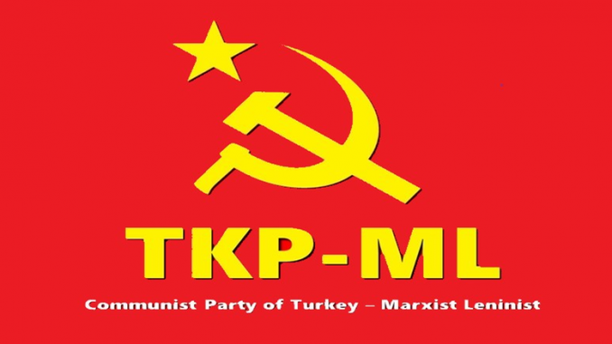

Link: https://www.tkpml.com/tkp-ml-cc-polit-bureau-happy-49th-anniversary-to-our-party-established-in-the-light-of-the-paris-commune/

