Welcoming more new storms on the horizon:

Victory to the militant independent Haft-Tappeh Sugar workers in Iran, on their 50th day of all-out strike!

The world is witnessing a new upsurge in the resistance and the struggle of workers and other oppressed against the capitalist system threatening the very existence of imperialism and all reactionaries. The rising tide of resistance and struggle is gathering momentum in all continents. Particularly in the Middle East, the scene of decades of imperialist rivalry, war by proxy and domination of reactionary states and forces and countless genocides and barbarity against the people, despite the rapid deterioration of conditions following the spread of coronavirus, everywhere voices of resistance and rebellion can be heard. From occupied Palestine to Lebanon, Iraq, Iran and Turkey, militant popular mass resistance has shattered the dreams and aspirations of the imperialist powers and their lackeys to impose a graveyard peace in the region. One example is the ongoing heroic resistance and all-out strike of Haft-Tappeh sugar workers in Iran.
On the 3rd of August, 2020, the 4,500 strong militant independent workers of Haft-Tappeh Sugar Factory in the city of Shoosh, in southwestern Iran, will begin their 50th day of all-out strike for their rights, demanding 4 months unpaid wages; prosecution of the corrupt owners of the factory; the unconditional release and freedom for all imprisoned workers and their colleagues; return to work of all sacked employees; and, more importantly, their central demand to end all privatisation initiatives by the government. This is the second major strike of the militant independent workers of Haft-Tappeh in 2 years. The last militant strike was the prelude to the large scale and widespread mass protests by the urban poor that shook the pillars of the regime of the Islamic republic. In December 2017 and January 2018 over 90 cities across the country rose in rebellion in protest against austerity measures and price hikes by the reactionary regime. Hundreds were arrested. While for months the sporadic protests in different places continued, in November 2019, a new surge of mass rebellion shook the crisis-ridden regime. This time over 190 cities were the scene of massive and prolonged resistance and protests by the urban poor and broader sections of society.
The militant strike of the Haft-Tappeh Sugar workers will enter its 50th day during the rise of coronavirus pandemic in Iran, a country under the rule of the regime of the Islamic republic with one of the worst records of mismanagement and containment of the disease. Notwithstanding this, the militant workers are protesting in the streets of the city of Shoosh, tolerating a 50+ centigrade heat wave and enjoy the widespread support by the population across the country.
The notorious regime of Islamic republic that has a 40-year history of crimes and atrocities against the oppressed peoples of Iran, wearing an anti-American cloak claims all economic hardships are the result of the US sanctions and the undeclared war between the two countries. Yet the militant workers of Haft-Tappeh have complied evidence and proven beyond any shadow of a doubt that the current plight of their enterprise, located in one of the most fertile regions of the Middle East and dating back to several thousand years of agriculture and food supply, is solely due to corruption and squandering at the highest levels of the state. As a result, the owners of the factory have been arrested and put on a show trial under crimes of currency speculation and corruption. Some of their closest associates in the central bank and the government are also implicated in this scandalous affair exposing the utterly devastating policies of the regime that is aimed solely at lining the pockets of their cronies and relations with windfall loots from auctioning off of national assets. The workers have also proven that since the privatisation of the Haft-Tappeh Sugar Factory 4 years ago, and the deregulation of imports that has allowed cronies of the regime including the IRGC (Army of Guardians of the Islamic Revolution) corporation, to import sugar and other supplies from abroad they have forced many companies and producers to go bankrupt or reduce their production capacity. They have also shown that because of the above and the mismanagement of the company, production has been reduced from 80 thousand tons of sugar prior to privatisation to 18 thousand tons during the last year.
The story of the sale of this factory to a private consortium composed of cronies of the regime including families and relations of those in power at a price equal to one-thousandth of the actual value of the factory 4 years ago, has found resonance in other industries too. The widespread auctioning off such public industries and national assets includes vast national forests, mines, steel industry, tractor factories, and others and the public services. This has aroused deep anger and indignation amongst the population. Even sections of the ruling classes who have not profited as much by all these corrupt dealings are raising their voice and demand answers.
As if the auctioning off of the companies and national assets to domestic private financiers and tycoons was not enough, the highest levels of Islamic Republic have been in secret negotiations with the Chinese imperialism to auction off the rest of country, on a 25 years lease. The full details of this agreement have not been published. They are being kept secret despite vocal demands for their publication even within the handpicked members of the Islamic parliament.
In the meantime, the regime continues to suppress the unprecedented rise in the workers’ struggles across the country, threatening and intimidating the protesting workers and their families. Many workers are arrested with on trumped-up charges and given long prison sentences. Workers leaders from various industries including from those from Haft-Tappeh and Ahvaz Steel Factory have been arrested on trumped-up charges, and many following their release from prison have been sacked. These include workers’ representative Esmail Bakhshi from Haft-Tappeh Sugar factory and Meysam Al-Mahdi from Ahvaz Steel factory and many others who continue to serve long prisons sentences.
The current surge in the workers' struggle in Iran that was sparked off in March 2020, by the militant copper miners in Kerman and now continues in Haft-Tappeh in Shoosh, on its 50th day of all out-strike certainly is based on the worsening and dire economic conditions. But, during the past 5 years, there has been a significant transformation in the workers' movement and their militancy in such strikes and protest actions. These struggles are no longer merely spontaneous and sporadic protests or strikes based in a factory. The strikes inevitably spread to the rest of the city and are supported by the other workers and the oppressed. In fact, the demand of workers across the country that is voiced by the militant Haft-Tappeh Sugar Workers struggle that is bringing focus on the ending of privatisation of public assets is a direct challenge to the corrupt and reactionary regime of the Islamic republic. This central demand of the worker now has found sympathy in other industries and sectors including education, health, retired personnel and their underground associations.
Since its founding in February 1979, the regime of Islamic republic through the imposition of retrogressive labour laws and reactionary anti-labour measures such as imposing “Islamic workers councils” has legalised the maximum exploitation of the workers and other oppressed by the capitalists and their institutions. It has also made the formation of independent trade unions and associations illegal. Nevertheless, such militant and legitimate organisations do exist and have been engaged in the struggle for decades. A noteworthy point, however, is that in the last few years under the condition of severe repression they have evolved attempting to improve the coordination and unity in their common actions in defence of workers’ right and just demands across many industries across the country.
The workers in their struggles have exposed the true nature of the Islamic republic regime as the instrument of the imperialist system, the comprador bourgeoisie, and the representative of the most reactionary and corrupt sections of the ruling classes, in Iran. Today, the Iranian workers that have over 120 years of history of engagement in the class struggle are entering a new phase to put their mark on the history of the country.
We take this opportunity to hail the struggle of the militant workers of Haft-Tappeh and extend our revolutionary greetings, solidarity and support for our common cause on the 50th day of their militant and inspiring resistance. On behalf of the workers and the oppressed in Turkey, we extend our solidarity and support to the workers and other toiling masses in Iran and condemn the ominous collaboration of the reactionary ruling classes in Iran and Turkey in their war and repression against the people of both countries and the region.
We condemn the handover of militant Iranian refugees escaping persecution in Iran by the fascist Turkish state. We condemn both reactionary and fascist regimes for the case of three young militants, Amirhossein Moradi, Mohammad Rajabi and Saeed Tamjidi that have been condemned to death in Iran accused of their involvement in the November 2019 protests and following their handover to the Iranian regime by the Turkish authorities.
We condemn the expansionist and adventurist policies of these two fascist regimes that hand in hand with the imperialist powers and their rivalries have turned the middle east into a devasting war zone.
Our party in our recent statements and analysis has pointed to the pending storms on the horizon and has called on all our comrades and fraternal parties to prepare and raise the banner of the proletarian internationalism and join forces, to seize the day and to advance the cause of revolution against the whole imperialist system and the reactionary and puppet states.
The widespread militant anti-racist struggles in the US and other struggles across the world amid the spread of coronavirus and the economic devastation compounding the existing economic crisis are all components and aspects of an international class struggle that must eventually be directed by proletarian parties capable of leading these struggles to victory. In Iran, and other countries in the region and across the world, many such parties do not exist or have been weakened through years of intense repression by the ruling classes and their imperialist backers. However, we must all recognise that this weakened state is more to do with the consequences of the domination of modern revisionism and opportunism that has undermined the power and the capability of the international proletariat. The restoration of capitalism in Russia in 1956 and then in China in October 1976 has brought untold damage to the international communist movement and has facilitated the spread of revisionism in all countries paralysing the revolutionary movement. Yet all the contradictions of the imperialist system that led to October revolution in 1917 and the victory of Chinese Revolution in 1949 and other liberation struggles in the 20th century, continue to exist in a much more acute and critical level.
Genuine proletarian parties that emerge with deep links within the working class are not formed in glass houses or as detached entities nor are they formed online in the abstract. They can only be formed within the heat class struggle and be tempered through direct engagement in the day to day struggles injecting the latest revolutionary theories into the practice of workers engaged in the class struggle. Our party is no exception. The founders of our party TKP-ML, led by comrade Ibrahim Kaypakkaya, were deeply inspired by the heroic and militant workers’ strike on June 15-16, 1970 in Turkey. It was the engagement in this tremendous struggle, the ensuing ideological struggles and the rupture from revisionism that led to our party’s foundation in April 1972. This year we celebrated the 50th anniversary of this great workers’ resistance that was a major turning point in the history of the class struggle of the workers against the capitalist class in our country. Throughout this period of almost 5 decades, our party has suffered countless losses and setbacks. We have lost 4 general secretaries and numerous cadres in the struggle against the ruling classes and their fascist state in Turkey. But every set back has fertilised the ground for the recovery and intensification of our struggle.
In our last congress, in April 2019, suffering the effects of the most concerted attacks against our party, the arrest of some of its leading figures in Germany in 2015 that was followed by a liquidationist split, our party recognising the importance of the role of our party in the region upheld the decision to intensify our internationalist role in the region and make every effort to build bridges throughout the region with revolutionary forces and the militant struggles including those of workers, women, youth and national minorities.
We call on all our comrades and our fraternal parties and reiterate our call to let us join to realise this critical and urgent need, to render every support for the just struggles of the peoples of the region and to find solutions to our common problems and serve the people in their revolutionary and just struggles for liberation from the yoke of imperialism and all reaction.
Capitalism has given birth to its own gravediggers. Only the proletariat and its vanguard have the historic mission to rally, unite and lead the struggles of the oppressed masses and direct the revolutionary effort to smash the state machinery of the bourgeoisie and to end the rule of imperialism and all reaction.
---
Let us prepare for the coming tremendous revolutionary storms!
Long live proletarian internationalism!
Long live the democratic and anti-imperialist struggles of oppressed peoples of the Middle East!
Victory to the revolutionary proletarian forces in Afghanistan, Iran, Iraq, Kurdistan, Lebanon, Palestine, and Turkey!
Victory to the militant workers of Haft-Tappeh and other workers in Iran!
Down with all imperialism and reaction!

Communist Party of Turkey - Marxist-Leninist
TKP-ML - International Bureau
August 2020
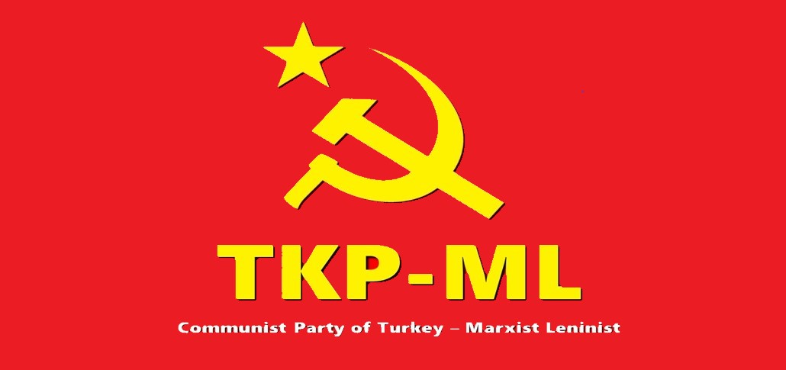

Link: https://www.tkpml.com/tkp-ml-international-bureau-solidarity-with-the-strike-of-the-haft-tappeh-sugar-workers/

